UPDATED Itinerary
Bhutan 2026 Pilgrimage
With Michelle & Joel Levey
September 22th to October 4th, 2026
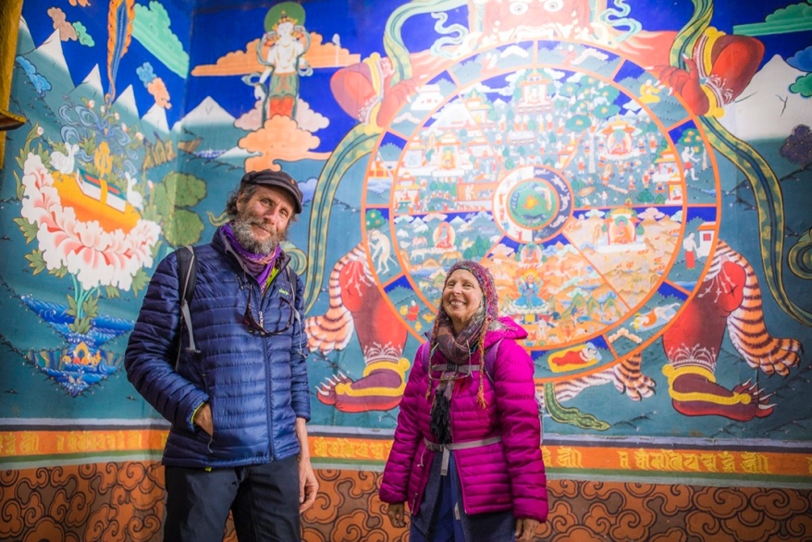
Plan to meet up at Bangkok Airport Hotel on September 21st
to fly into Bhutan together on the 22nd.

Day 1: Fly to Paro and Drive to Thimphu (7,700 ft / 2,334 m)

The flight into the eastern Himalaya reveals breathtaking views of the roof of the earth, world’s highest mountains. The soothing inflight flute music and beautiful views of hills dotted with stupas, prayer flags and monasteries will make you feel well come into the Happiness land. On arriving at Paro international airport, Bhutan Visa will be stamped on your passport and at the exit point you will receive by our representative who will escort you where all the arrangements have been made.

Drive (55 km / 34 miles, ~1.5 hrs) to Thimphu, Bhutan’s charming capital. Sightseeing depending on time or at leisure.

Circumambulate the memorial stupa for the 4th king and meditate at sunset with the community there. This stupa was designed by one of our teachers, Dudjom Rinpoche.
Perhaps we’ll have the good fortune to enter inside the sacred stupa to behold one of the most remarkable sacred sculptures in our world.
Overnight at hotel

Day 2: Thimphu Festival
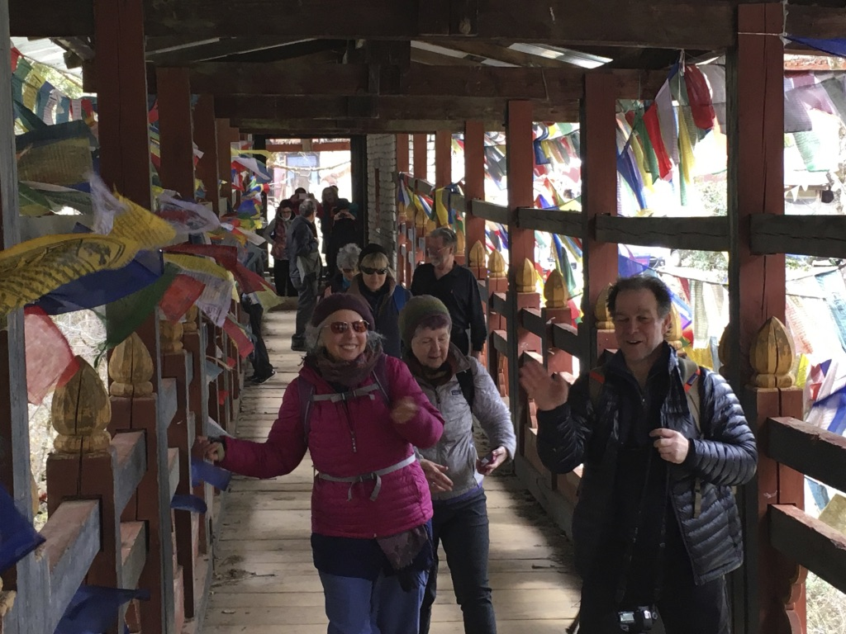
Enjoy half day of festival dances and celebrations with the people of Thimphu at the famous Thimphu Tshechu Festival. This festival is packed with spiritual performances like sacred mask dances (Chams) and cultural displays at the Tashichho Dzong, a core part of the three-day event celebrating Guru Rinpoche, offering deep dives into Bhutanese Buddhism, spirituality, and community vibrancy. Festivities take place in the courtyard of the magnificent Tashichho Dzong(the fortress of the glorious religion) in Thimphu. Expect vibrant costumes, traditional music, and a lively atmosphere.

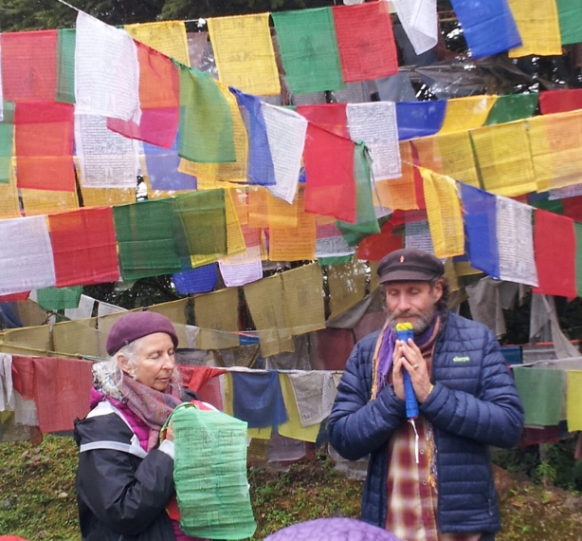
Tashi Chhoedzong, known as the “Fortress of Glorious Religion.”

Visit the exquisite Tara Temple established by the Queen Mother and receive precious teachings on the Goddess Tara and her mantra.

Visit the Giant Buddha Dordemna Statue overlooking the Thimphu Valley and behold the remarkable artworks in the temples there.

Overnight at Hotel

Day 3: Thimphu drive to Punakha (4,265 ft / 1,300 m)

After breakfast drive to Punakha, an ancient capital of the country, en-route Dochula pass. The Dochula pass (10,300 ft / 3,140 m) offers a breathtaking panoramic view of the Himalayan range, especially on clear winter days. Dochula pass house’s the 108 Chorten also known as the Druk Wangyal Chorten and retreat huts in the mountains there.
We will have prayer flag hoisting here in the premises for the blessings of sentient beings and one self.

The road from pass winds down into subtropical valley, once you reach Punakha valley, Hike through rice fields to Chimi Lhakhang (Temple of Fertility).

In the evening, we will visit Punakha Dzong Bhutan’s most beautiful fortress.
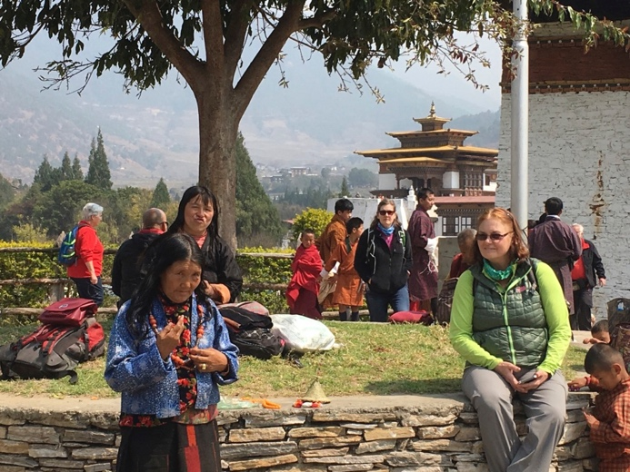
Overnight at hotel

Day 4: Punakha

Hiking to Khamsum Yulley Chorten- Kings temple. Blessing ceremony with monks in a centuries-old monastery – the Chorten Nyebu Monastic School. Overnight at hotel
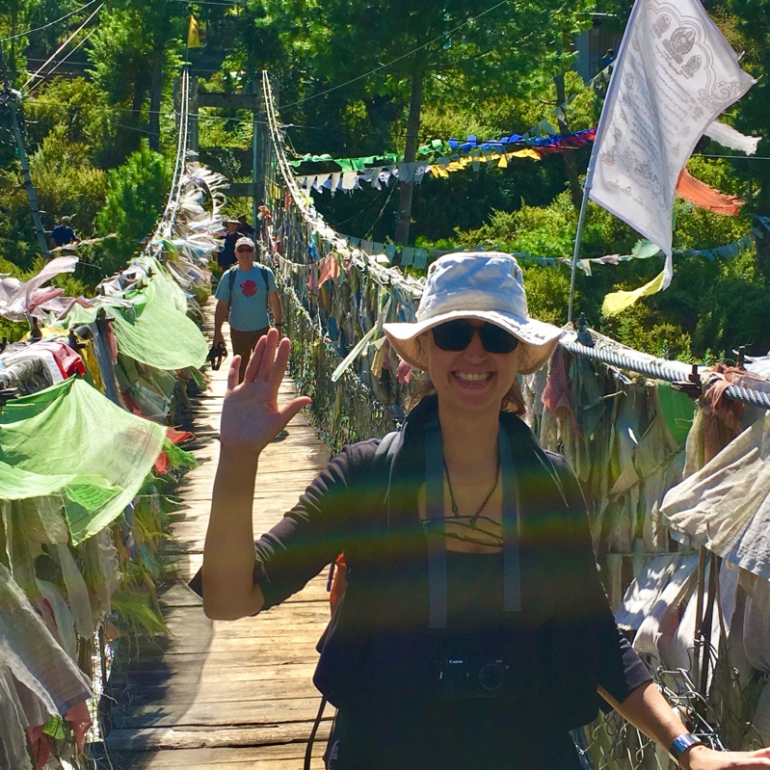
Day 5: Punakha drive to Phobjikha (9,800 ft / 2,990 m)

After breakfast drive (75 km / 47 miles, ~3.5 hrs) into the mystical Phobjikha Valley, winter home of the black-necked cranes, en-route Wangduephodrung, on the way visit Wangduephodrung Dzong, the historic Wangduephodrang Dzong has served as the seat of the District Monk Body and the District Administration of Wangduephodrang Dzongkhag.
Visit Gangtey Monastery, one of Bhutan’s most important Nyingma Buddhist centers.
Hike the Nature trail through pine forest known for forest bathing – feel rejuvenated

Join an evening prayer ceremony alongside monk at Gangtey Shedra.

Overnight at hotel.

Day 6: Phobjikha drive to Bumthang (8,530 ft / 2,600 m)

Today is one of the most Scenic drives (188 km / 117 miles, ~5 hrs) across high passes and pristine landscapes.

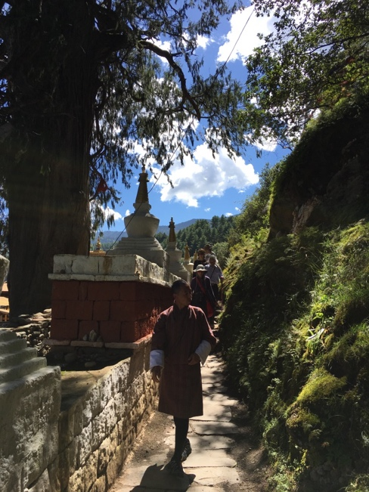
Visit Trongsa Dzong, the masterpiece of Bhutanese architecture and Ta Dzong
En route, visit the Yathra (textile weaving) where the Yathra are designed with patterns unique to Bumthang.
Arrive in Bumthang, the spiritual heartland of Bhutan.

Overnight at Hotel

Day 7: Bumthang
We will visit Kurje Lhakhang, one of the most sacred places in the kingdom as Bhutan’s “patron saint”, Guru Rinpoche (Padmasambhava) meditated here.

Meditations and teachings along The Way)))

After lunch visit Jambey Lhakhang. This temple, erected by the Tibetan king Songtsen Gampo in the 7th century, is one of the two oldest in Bhutan.

Visit Tamshing Lhakhang (built by saint Pema Lingpa) one of the oldest Nyingmapa monastery in the world.

Overnight at Hotel

Day 8: Bumthang

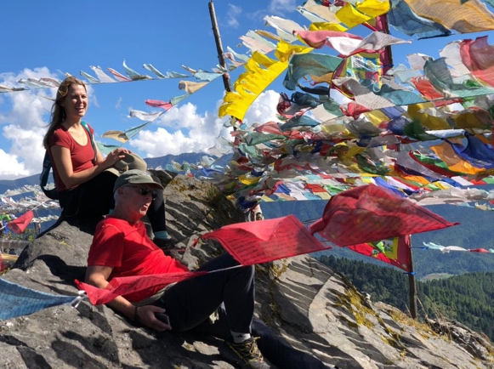
Today, you will make an enjoyment excursion to the Tang valley, which is most remote valley in Bumthang. While in the Tang, you will visit 16th century Ugyen Chholing Palace, which is now turned into a museum. The well – captioned exhibits offer insights into lifestyle of a Bhutanese noble family.

Visit Nimalung monastery for offering of 108 butter lamps. On the way back, you will visit Mebar Tsho (Burning Lake), where some of Guru Rinpoche’s treasures were found in the 15th century by the famous treasure discoverer Pema Lingpa.

Overnight at Hotel

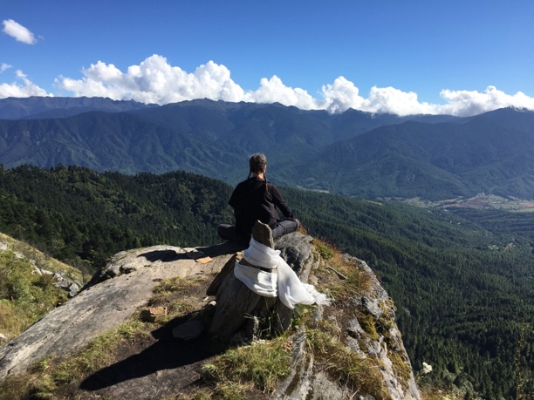
Day 9: Bumthang

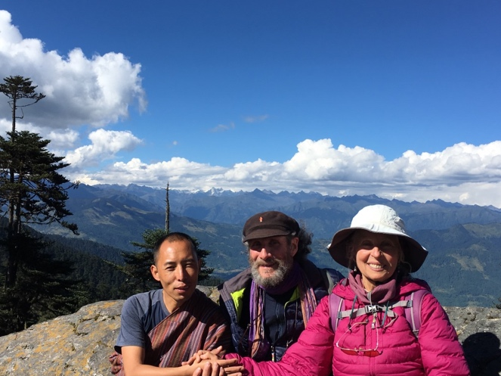
Today, you will make a sacred pilgrimage to the Tharpaling Monastery, established by the Great Longchen Rabjam. Meditations and prayer ceremony at Tharpaling monastery, then hiking to the hermitage at the high ridge above the monastery with vast views of the valley and the snowcapped Himalaya range. Descend via the memorial stupa for Nushul Khen Rinpoche, one of our beloved teachers, who composed the famous “Rest in Natural Great Peace” poem. Overnight at hotel

Day 10: Bumthang fly to Paro (2,200m / 7,218ft)

After breakfast drive to Bumthang airport for departure for a short flight to Paro with vast views of the snowy peaks of the Himalayas to Paro.Sightseeing depending on time. Visit Rinpung Dzong “fortress of the heap of jewels”, Kyichu Lhakhang. Overnight at hotel

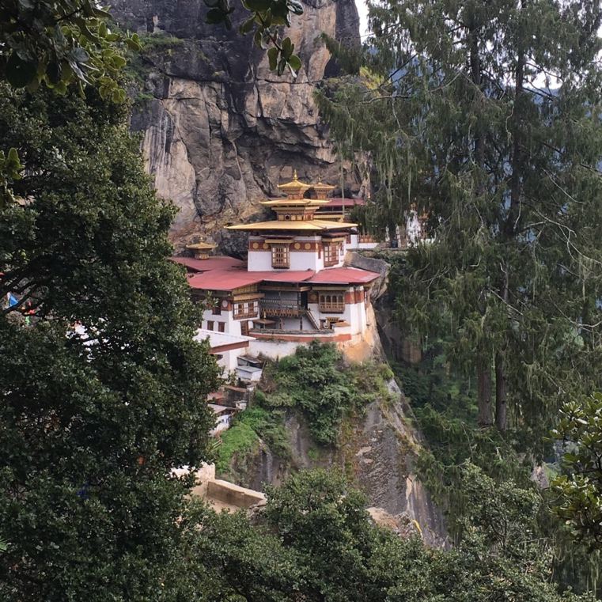
Day 11: Iconic Taktsang – Tiger’s Nest (3,120m / 10,240ft)

After breakfast today, we will drive to the base of the Taktsang & prepare for the hike to the Taktsang monastery (tiger’s nest). This magical monastery clings to a vertical granite cliff 900m above the valley, where the only sounds are the murmurs of wind and water and the cracking of the prayer wheels. The legend of Taktsang dates back to 747AD when Guru Padmsambhawa is arrived at this site and manifested riding on the back of a tigress to subdue the evil spirits in the region. The Guru then meditated in the cave that is site of the Pelphug Lhakhang today. The whole pilgrimage is estimate to be a 4 to 5 hour round trip excursion. Overnight at hotel

Day 12: Integration Day and visit to the inspiring home and monastery of the great Dilgo Khyentse Rinpoche, one of the most beloved teachers in our lineage. Time to reflect and harvest the treasured learnings of our time together, shopping, and sightseeing in the Paro Valley. Overnight at hotel

Day 13: Short Drive to Paro International Airport for Departure

Our pilgrimage route is just south of the tall peaks of the Himalaya mountain range.
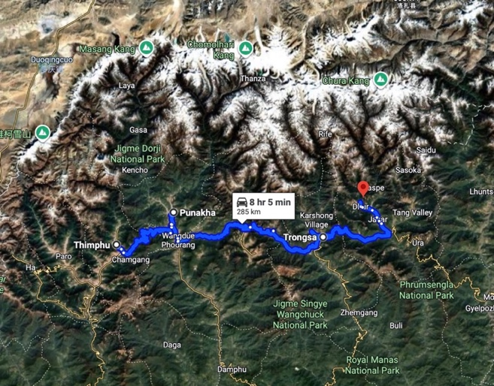

For a glimpse of previous Bhutan pilgrimages that we have guided please enjoy these videos:
https://www.youtube.com/watch?v=6TfuVBOnqyU&t=87s
https://www.youtube.com/watch?v=JLA7NtEiwIE&t=9s

